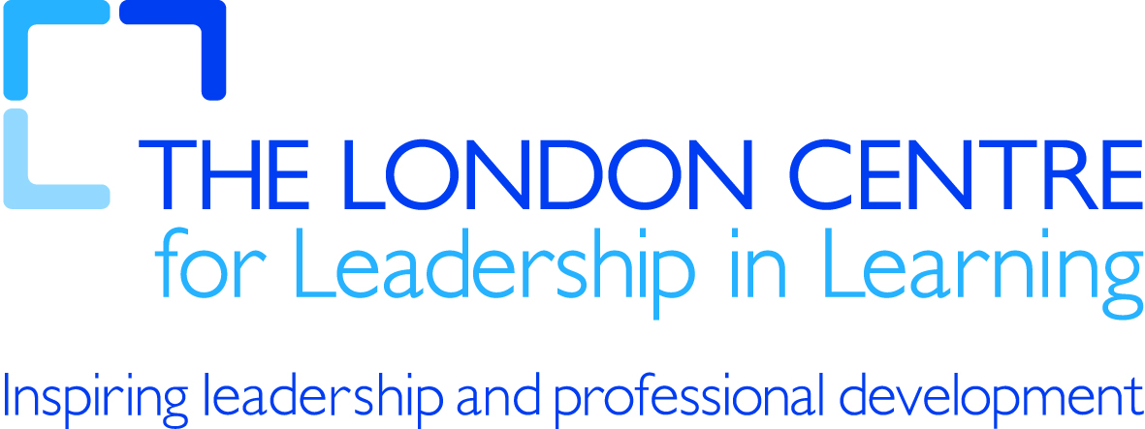

21st century tools for teaching and learning

Notice boards

What is it? | - Canvas with sticky notes  - Text, we blinks, images, files, multimedia  - Public/Private/Group  - Unique URL to send to users  - Embed it into your website
In what context? | - Brainstorming on collaborative projects  - Outlining tasks  - Organising your thoughts  - Re-arranging ideas/contents  - Ice-breaking activity
Specific example contexts? | - Ask your students write their opinions on a topic  - Post a video on to the wall, ask a few questions and have your students write their responses  - Ask your students to post the words they have learnt that week on to the wall
What services could I use? | - http://en.linoit.com/  - http://hello.corkboard.me/  - http://www.wallwisher.com/build

