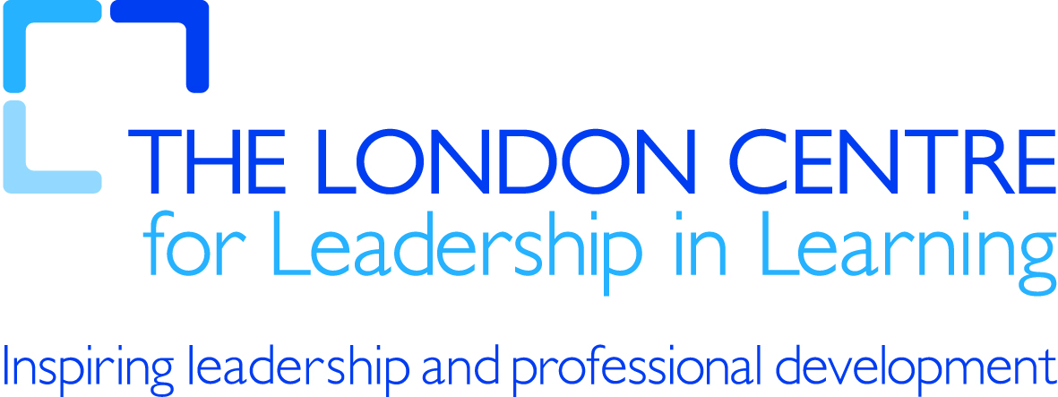

21st century tools for teaching and learning

Multimedia posters

What is it? | - Multimedia collage builder  - Mash together online or student generated:  - video clips  - audio clips  - Text  - Images  - Interactive
What can it be used for? | - Creative self expression  - Multisensory learning experience  - Individual or collaborative
How could it be used in teaching and learning? | - Individual/group project  - Suitable for any subject  - develops creativity and inventive thinking  - develops visual literacy
What services could I use? | - http://edu.glogster.com/

