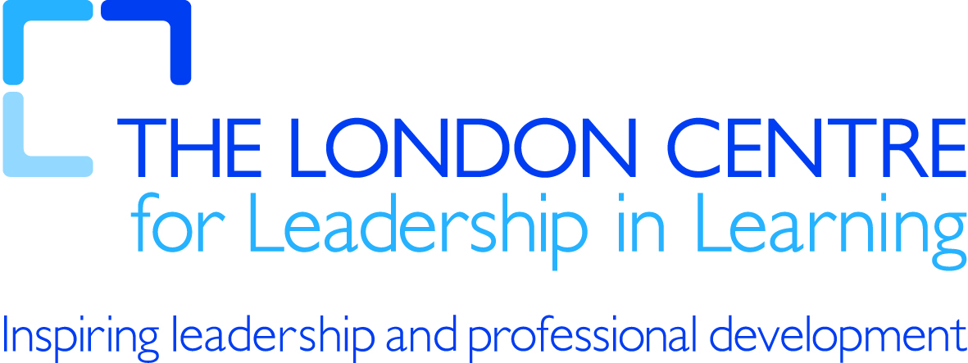

MIND MAPPING – 2
Some suggested contexts for use of mind mapping tools.

In the Classroom
A Mind Map is the ideal teaching aid, as it can naturally take the learner from the known to the unknown, which is a fundamental principle of learning. The teacher starts with the main concept or principle in the middle and gradually drills into the details at a pace that can be followed by the class. The same Mind Map notes can then be used by faster and slower pupils, as the pace is dictated by the class, not the teacher. The learner is at the centre of the learning process all the time.

Brainstorming and Clarify thoughts
Mind Maps allow you to clarify your thoughts by categorising them and grouping them into related ideas. This allows remarkable clarity when thinking. You are able to do quick Mind Map brainstorms and then easily reorganise your thoughts in a structured way. This will naturally lead to clearer and better thinking without losing the creativity.

Analysing
To analyse a complex problem, you have to look at it from different angles. A Mind Map allows you to put down the different angles on a single page, record your thinking in each of the angles, and then compare and analyse them in a structured way, without losing the 'thinking out of the box' benefits.
By focusing on one branch at a time, you can explore the idea fully without letting the others getting in the way. Yet, if you need access to the other ideas, they are right there. With some Mind Mapping tools (e.g. www.mindmeister.com) you can easily hide the other ideas while you are focusing on one. The others are just a click away!

www.usingmindmaps.com

