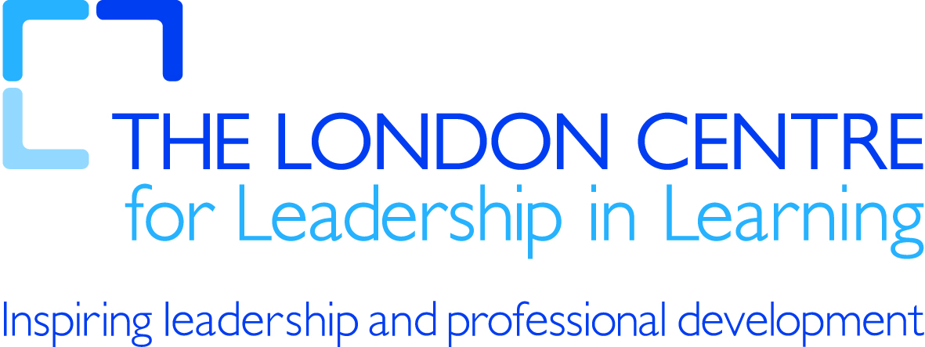

MIND MAPPING – 1
How they aid learning

Note Taking/Note Making
We classify writing into two classes: Note Taking, which takes down other peoples’ ideas, and Note Making, which you use to record your own ideas. In both Note Taking and Note Making, Mind Maps allow you to combine both other peoples’ ideas and your own on the same Mind Map, in a way that complements each other.

Organising your thoughts
While a Mind Map may look messy for some, it is actually a very structured way of note taking and note making. While it is very structured, it is also very creative. Structure and creativity are often looked at as to opposing and contradicting forces. With Mind Maps, these two powerful forces work together in a synergy that is hard to reproduce in any other way.
People with a structured approach are often labelled left-brained and the creative ones are often labelled right-brained. These terms were coined based on the parts of the brain that are associated with structured and creative thought, respectively. With Mind Maps you combine both and become whole-brained.

Aiding memory
Association and hierarchy are two key components in memory. Mind Maps naturally apply both of these principles. All ideas are linked via defined paths in a Mind Map. The associations between ideas are therefore clearly defined. Maps also naturally go from the most important, central topic, to more and more detailed topics, using thinker lines in the beginning and thinner ones for the detail. This creates a natural hierarchy.

www.usingmindmaps.com

