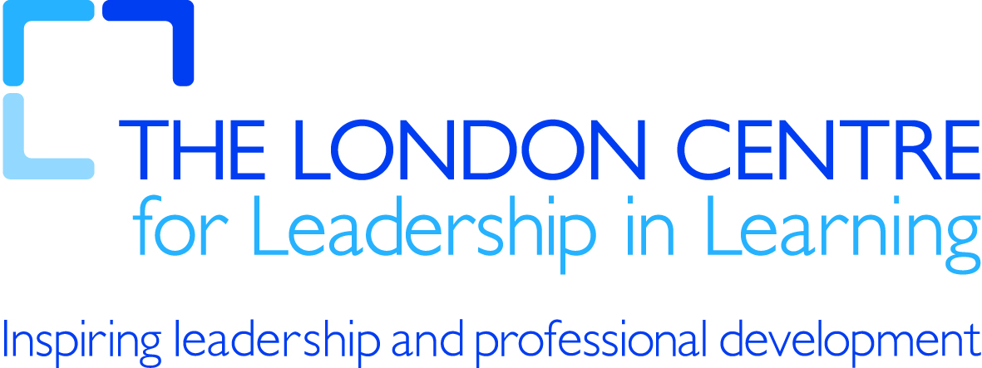

Map tools

Some ideas for
Art History
  - Search for photos and user-created maps showing famous museums like the Louvre in Paris.
Biology & Ecology
  - Track routes of chimpanzees in Tanzania's Gombe Forest. See the Jane Goodall Institute Chimpanzee blog here.
  - Create a short quiz like this one.
Environmental Science & Climatology
  - Have students check Alaska's global warming problems. See how the Sierra Club used Google Earth to depict this problem here.
  - See how Google and the United Nations Environment Programme teamed up to use collaborative MyMaps for the International Cleanup Weekend Initiative.
  - Use this Google Maps Mashup to locate and learn about recent earthquakes around the world.
  - Celebrate the 2007-2008 International Polar Year and add your classroom's plans to this global map.
Geology
  - Find images, links, and descriptions, with information about thousands of volcanoes around the globe, thanks to organizations like the Smithsonian Institution's Global Volcanism Program.
Global Awareness
  - Study the Crisis in Darfur with the US Holocaust Memorial Museum's unprecedented project.
History:
  - Explore Tutankhamun's Tomb.
  - Take a virtual tour of the 21 California Missions.

Literature & Humanities
  - Bring class or contemporary tales to life with Google LitTrips.
  - Have your students scout film shoot locations like this teacher did with The Golden Compass.
Math
  - Explore distance, velocity, and wave properties of tsunamis.
Physics
  - Learn how one teacher used Google Maps with his 9th grade class to teach speed, velocity and displacement.

